Email Spam Classification

Project Report
……….
Author: Brindha Devi S.P,

Project Type: Individual Project

Git Repo Link:

EXECUTIVE SUMMARY:
➢The Email Spam Classification Project is a machine learning–based system designed to automatically classify email messages as Spam or Ham (Not Spam). The system uses Natural Language Processing (NLP) techniques and a Naive Bayes classifier to analyze the textual content of emails and detect spam effectively.
➢ The application processes a labeled email dataset, performs text vectorization using TF-IDF (Term Frequency–Inverse Document Frequency), and trains a Multinomial Naive Bayes model to classify messages. Model performance is evaluated using accuracy and classification metrics. This project demonstrates the practical application of NLP and machine learning in solving real-world problems related to email security and filtering.

PROJECT OVERVIEW:

Objective:

To build an efficient email spam detection system using NLP and machine learning techniques that can accurately classify messages as spam or ham.

Scope:

➢ Loading and preprocessing email dataset
➢ Text feature extraction using TF-IDF
➢ Training a Naive Bayes classification model
➢ Testing and evaluating model performance
➢ Displaying accuracy and classification metrics
Key Features

1. Dataset Processing
The project uses a labeled email dataset (spam.csv) containing spam and ham messages. Only the relevant columns are selected and renamed for clarity.

2. Text Preprocessing
Stopwords are removed using NLTK, and messages are converted into numerical feature vectors using TF-IDF Vectorization.

3. Machine Learning Classification
A Multinomial Naive Bayes model is trained to classify emails into spam (1) or ham (0).

4. Model Evaluation
The trained model is evaluated using:
- Accuracy score
- Precision, Recall, and F1-score (Classification Report)

5. Efficient Data Splitting
The dataset is split into training and testing sets using an 80:20 ratio to ensure unbiased evaluation.

TECHNICAL IMPLEMENTATION:

Technology Stack:
• Programming Language: Python
• Libraries Used:
- Pandas, NumPy (Data handling)
- NLTK (Stopwords)
- Scikit-learn (ML & evaluation)
• Feature Extraction: TF-IDF Vectorizer
• Machine Learning Model: Multinomial Naive Bayes

• Evaluation Metrics: Accuracy Score, Classification Report

IMPLEMENTATION DETAILS
- The dataset is loaded using Pandas
- Labels are encoded as:
  - 0 → Ham
  - 1 → Spam
- Text data is transformed into TF-IDF vectors
- The model is trained using training data
- Predictions are made on test data
- Model performance is printed using evaluation metrics

Performance Metrics:
• Accuracy: Measures overall correctness of classification
• Precision: Measures correctness of spam predictions
• Recall: Measures ability to detect actual spam emails
• F1-Score: Balanced measure of precision and recall
SOURCE CODE IMPLEMENTATION (Screenshot):

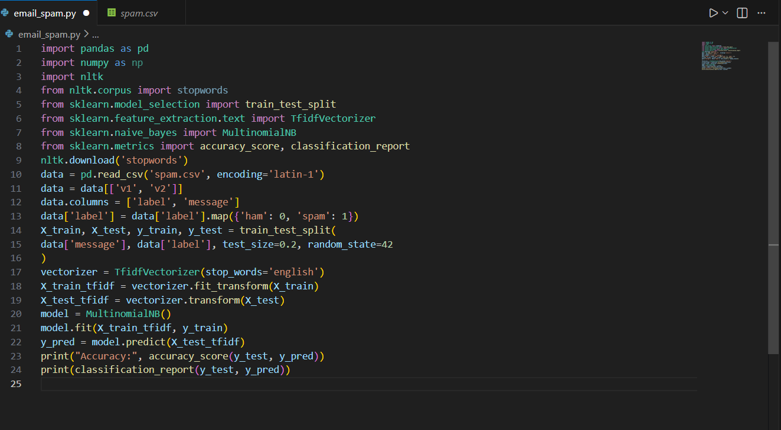

Extracted Job Result In Excel:

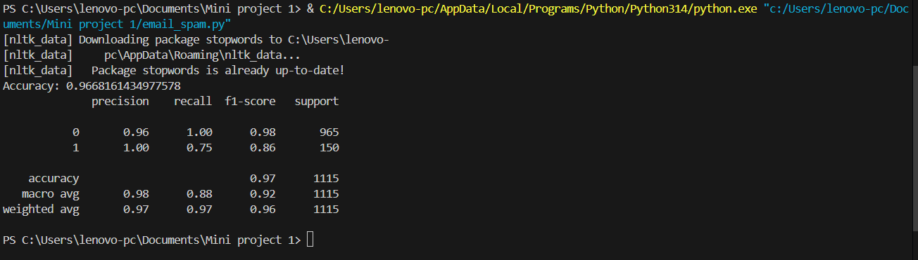

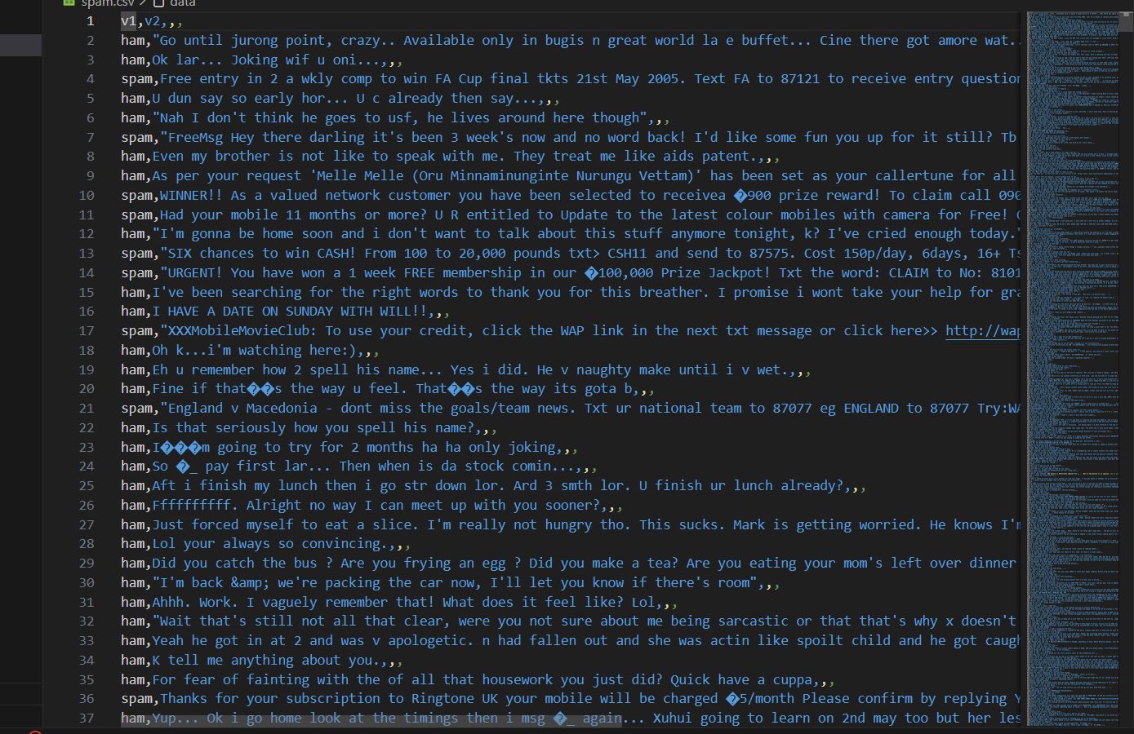

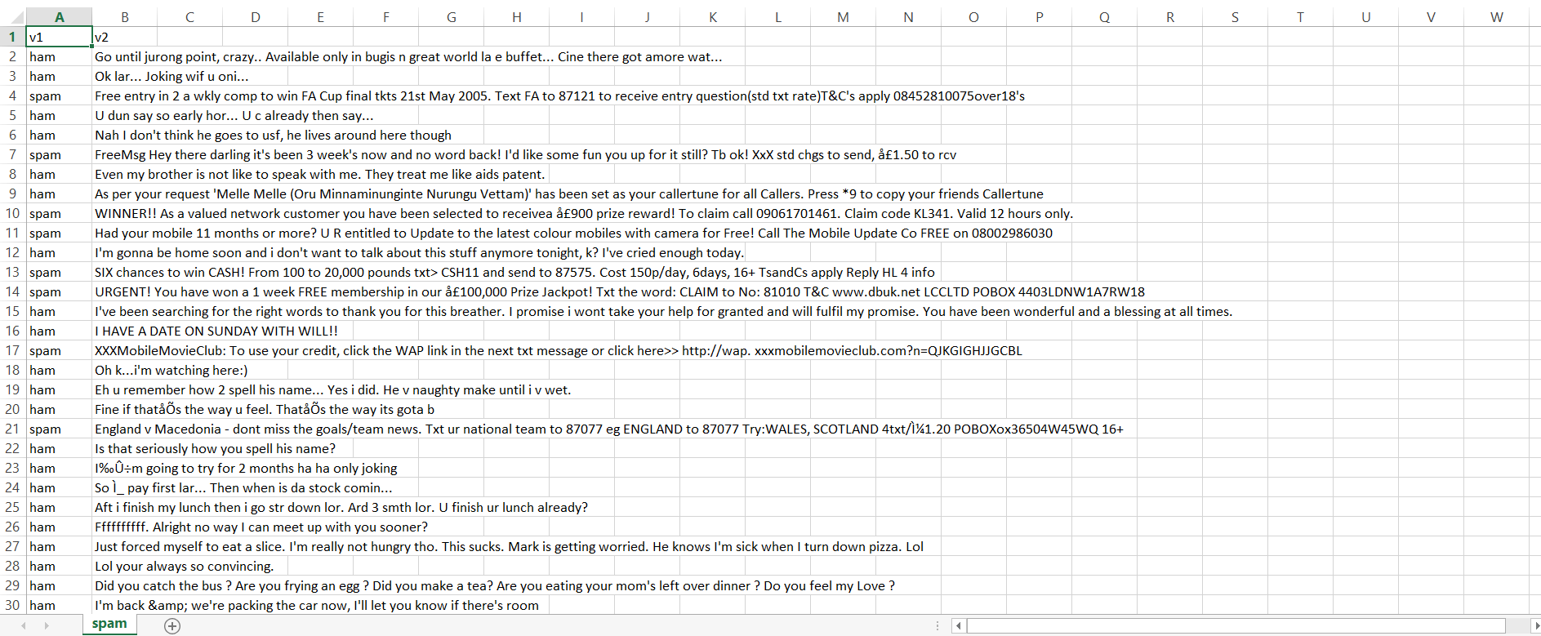

CONSTRAINTS:

Resource Constraints:
Model performance depends on dataset quality
• Cannot detect newly evolving spam patterns without retraining
• Only text-based spam detection (no links/attachments analysis)
• Dataset imbalance may affect predictions

PROJECT IMPACT AND VALUE:

Immediate Benefits
• Automatically identifies spam emails
• Reduces manual effort in email filtering
• Improves email security
• Demonstrates real-world NLP application
• Lightweight and fast classification model

Future Enhancements
• Use deep learning models (LSTM, BERT)
• Real-time email filtering integration
• Phishing and malicious link detection
• GUI or web-based interface

CONCLUSION:
The Email Spam Classification Project successfully applies TF-IDF feature extraction and Naive Bayes classification to detect spam emails with high accuracy. The project highlights how machine learning and NLP techniques can be effectively used to improve communication security.
This implementation serves as a strong foundation for advanced spam detection systems and can be extended with more complex models and real-time deployment.

